“How to enjoy Halloween when you don’t want to be seen”

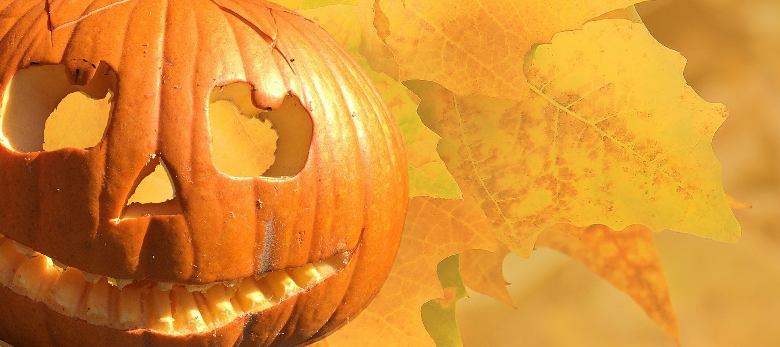

For some it is a time to have ‘fun and frolics’ and for others it is a time to ‘hide and not be seen’. I have mixed feelings on this event consisting of spooky story-telling, creepy crafts and the many ‘trick or treat’ trails that I have been accustomed to in the years gone by. However, given this year of change, unpredictability and the new ‘norm’ it is a welcomed event in my home. Halloween this year can be a time for spontaneity, positivity, joy, laughter and love for all. A time to ‘come together’ within communities and to enjoy humanity at its best; sharing and giving out lots of unconditional love to the world whilst having lots of fun!

“Do one thing every day that scares you”

I live by this saying dear reader, ever since the day my mother passed away. It has been so helpful and positive at pushing me forwards in my life. So I challenge you on today of all days to do just that “one thing that scares you”. After all it is in-line with it being Halloween, so jump! Scare yourself, and who knows you may actually enjoy the thrill!?

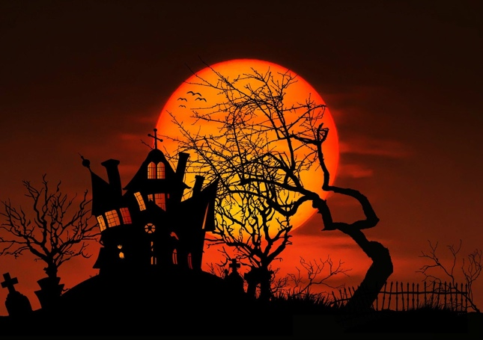

We at ‘Lengro’ love to have a good party and we will celebrate this day, even if we are all over the world. ‘Covid’ will not dictate to us how we spread our word and love to you all. We will be online later to give you a spooky story telling show, I’m sure of it, whilst brightening your end of October. Have you planned to ‘trick or treat’ tonight? It does not have to be done on the streets, you can always choose to play the game online with other friends and their children to keep your family entertained and safe at home. Zoom call dares and pranks on the phone are both safe options for you this Halloween so that ‘Covid-19’ does not spoil your Halloween fun.

Many find Halloween a challenging time as they wish to hide and not be seen. Many elderly wish to be left alone and fear being harassed by the minority who choose to be unkind during the festivities of Halloween. The elderly may be feeling vulnerable and so ‘Lengro community’ what can we do to support those in your community during Halloween? How about we all ‘pay it forward’ and spread the Halloween unconditional love by checking in on a fellow elderly neighbour on Halloween? Maybe you could take them a small offering of love and kind, like a baked cake or cookie. Perhaps choose to share a cuppa, and some time with them, if they would like to do so. Then they will know that they have your support for the upcoming evening festivities that the youth of our community love to partake in. We here at ‘Legro’ never want anyone to live in FEAR, only in LOVE, HOPE and JOY!

So how will you celebrate Halloween in a positive light this year? I know I will be celebrating Halloween by purchasing a set of the newly launched Tarot cards designed and made we both love and care by our very own editor and owner of ‘Lengro magazine’ Claire Petulengro.

So dear reader, help one another to make Halloween a positive and LOVE filled experience this year!

Have a good week!

Snooki xxx

